BROWARD COUNTY PUBLIC SCHOOLS (BCPS) GUEST WIFI ACCESS:

1. Access your Network Setting on your device
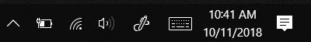
MAC PC

2. Select BCPS – GUEST (If prompted click Connect)
Your default browser will launch the Registration Page.
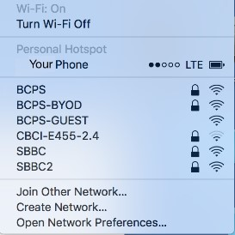
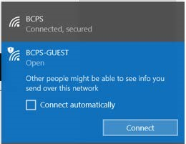
MAC PC

NEW USERS:

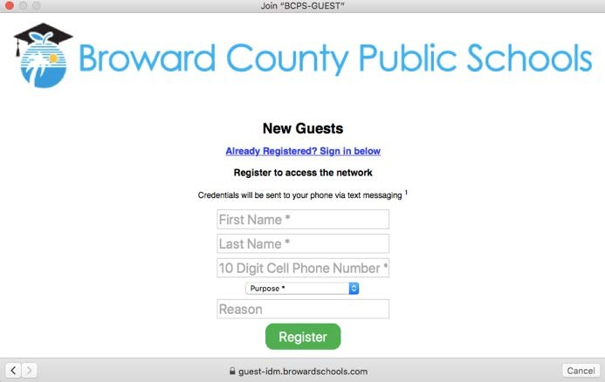
3. Fill in:
- First Name
- Last Name
- Cell Phone Number (no dashes)
- Purpose
- Reason
Click Register

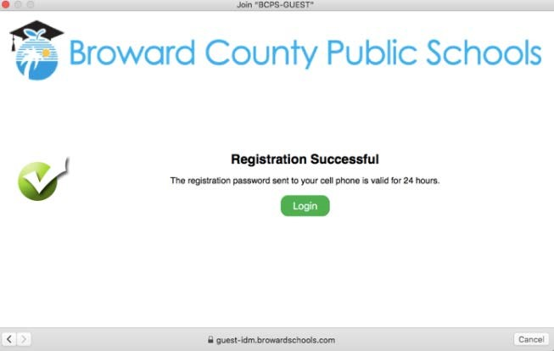
4. This Registration Successful screen will appear.
You are now Registered!

5. Click Login

6. An 8-character temporary password will be sent to your cell phone via text message.
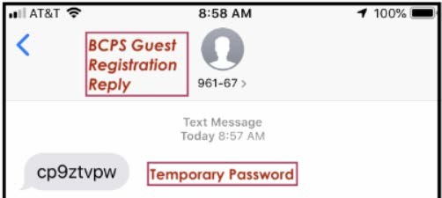
iPHONE ANDROID
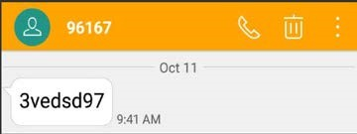

ALREADY REGISTERED:

7. Click Already Registered? Sign in Below.

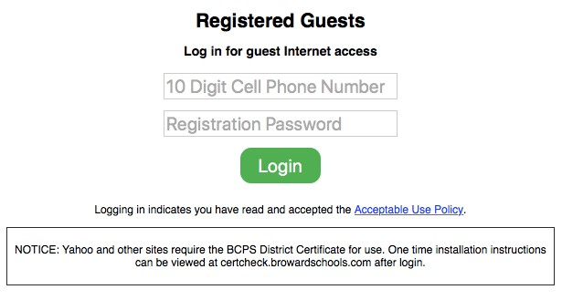

8. Enter:

- Cell phone number (no dashes)
- Temporary Password (received via text)
Click Login
* Note: Logging in indicates you have read and accepted
the Acceptable Use Policy.

9. You have successfully accessed the BCPS Guest
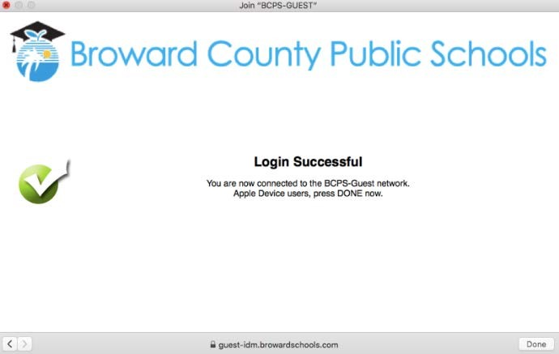
Wireless Network for up to 24 hours!

*If you receive a message asking for a certificate, this step may be required!

10. A one-time installation of the BCPS District Certificate
may be needed for Yahoo and other websites.
Open your browser and go to http://certcheck.browardschools.com
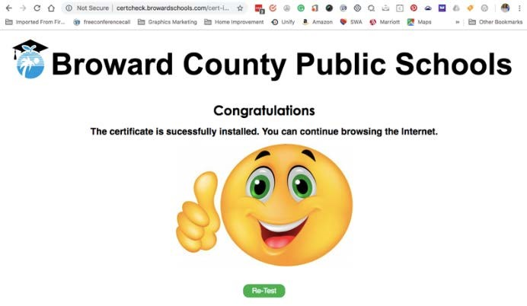
to get a BCPS Certificate and you will get a
confirmation screen that looks like this.

